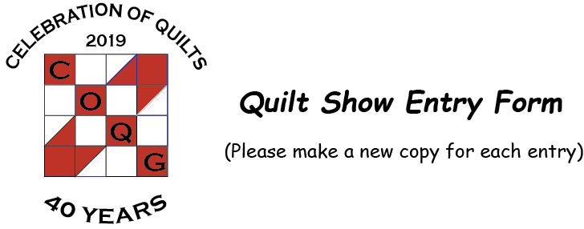 | Committee Use Only:
 | Category: |  | ID No.
Show Agreement: I have read the contest rules and hereby agree that by entering the COQG’s “A Celebration of Quilts 2019” , I will abide by the decisions of the show committee and judges. I understand that the show committee and its volunteers will take every precaution to protect my entry. I will not hold COQG or its volunteers liable for damages or loss beyond show insurance limits. Personal item insurance is my responsibility.
By entering I agree that any COQG sanctioned photo may be used by the Guild for any promotions, advertising, multimedia production, website, or show CDs relating to this event without compensation to me. Photography usage by other parties and permission to use will be between that entity and me.
I agree with the terms listed above. ☐
Member Information
Name: |  |  |  |  | COQG Member #:
Address: |  |  |  | City: |  | State:
Preferred Phone: Phone: |  |  | Email:

Quilt Information
Quilt Name: |  |  |  |  |  |  |  | Top Maker:
Quilted By: |  |  |  |  |  |  |  | Length: |  |  |  |  | Width:
Original Design? Yes ☐ No ☐  No ☐ |  |  |  |  | If answer is no, please complete designer credit information below:
Designer credit: (book, pattern, designer, inspiration source)
Techniques used:
Applique: |  | Hand ☐ | Machine ☐ |  |  | Piecing: | Hand ☐ |  |  | Machine ☐ |  | Foundation/Paper Pieced ☐
Embroidery: |  | Hand ☐ | Machine ☐ |  |  | Quilting: | Hand ☐ |  |  | Machine ☐ |  | Long Arm Machine ☐
Embellishment/Other Techniques:
Desired Entry Division: |  |  |  |  |  |  |  |  | Desired Category:
Quilt Story:
Tell something interesting and personal about your quilt. What was your design inspiration? How and why was the pattern and/or fabric selected? Was the quilt made for a special person or event? Has the quilt won any prizes (what, when, where)? Does the quilt have a special history?
Please keep your story to 150 words or less.

